**Create Free Tier Account in AWS**:

Step 1: open this url. <https://aws.amazon.com/free/>

Step 2: Click on below link given in screenshot. “create free account”

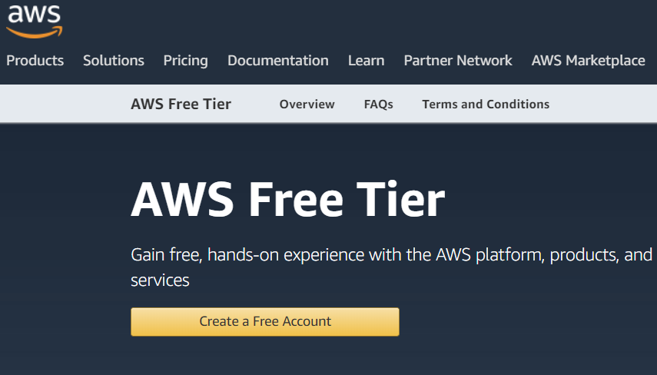

Step 3: Fill the below details.

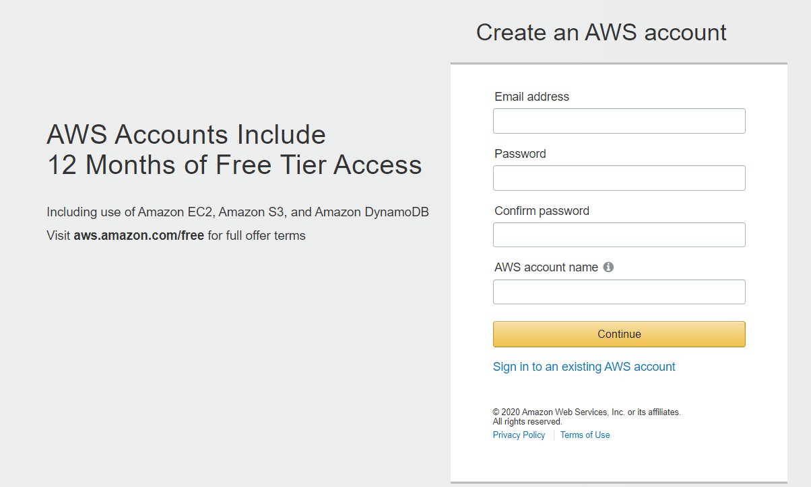

Step 4: Select “Personal Account” and provide your Address, mobile no and other info.

Step 5: Please provide your credit card info. It will debit 2 rs from your account for verification purpose and amount will be credited back to your credit card.

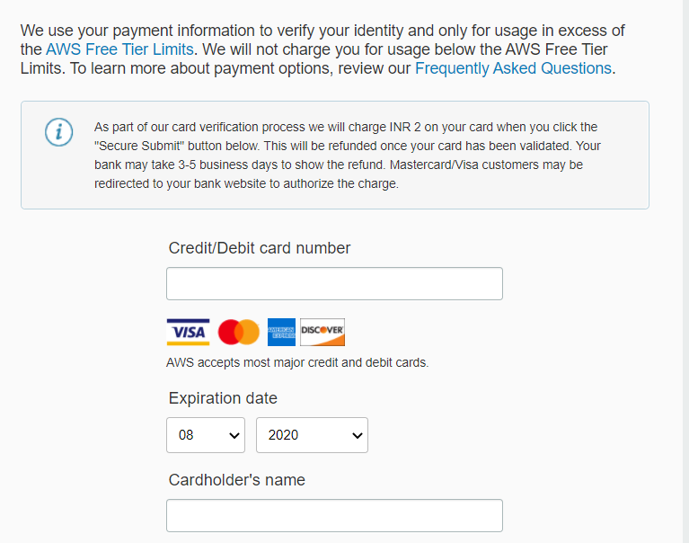

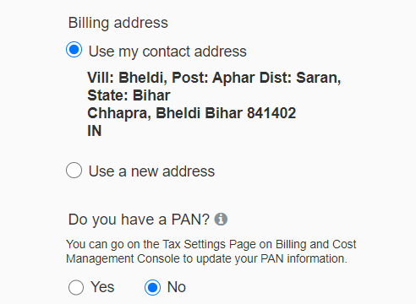

Step 6: Once you submit the above info, it will ask to confirm your identify and send you some verification code to authenticate. Please use below screenshot.

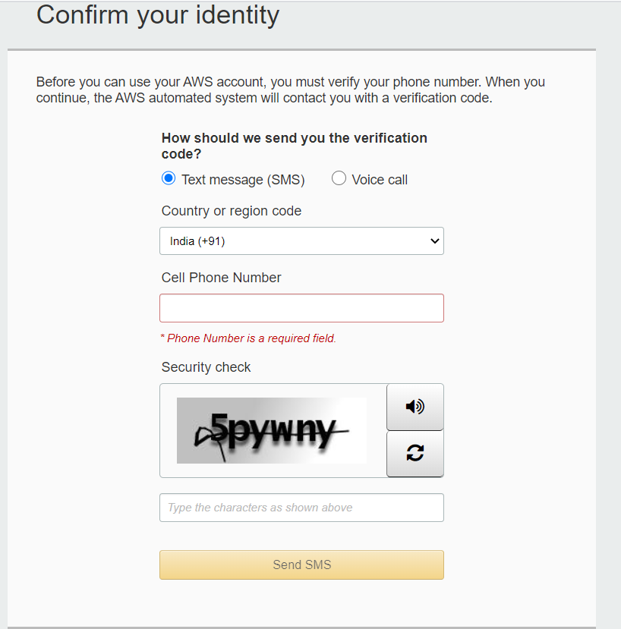

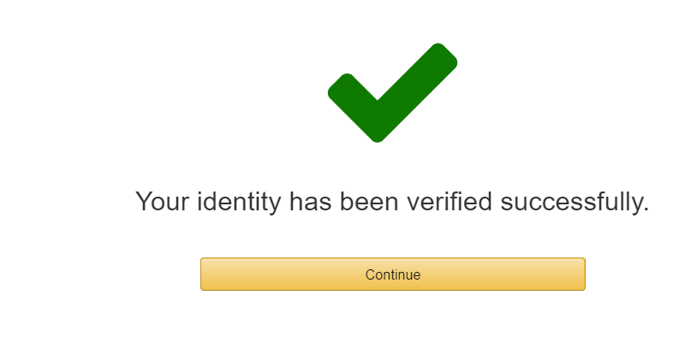

Step 7: Select the **Free Tier/Basic** plan.

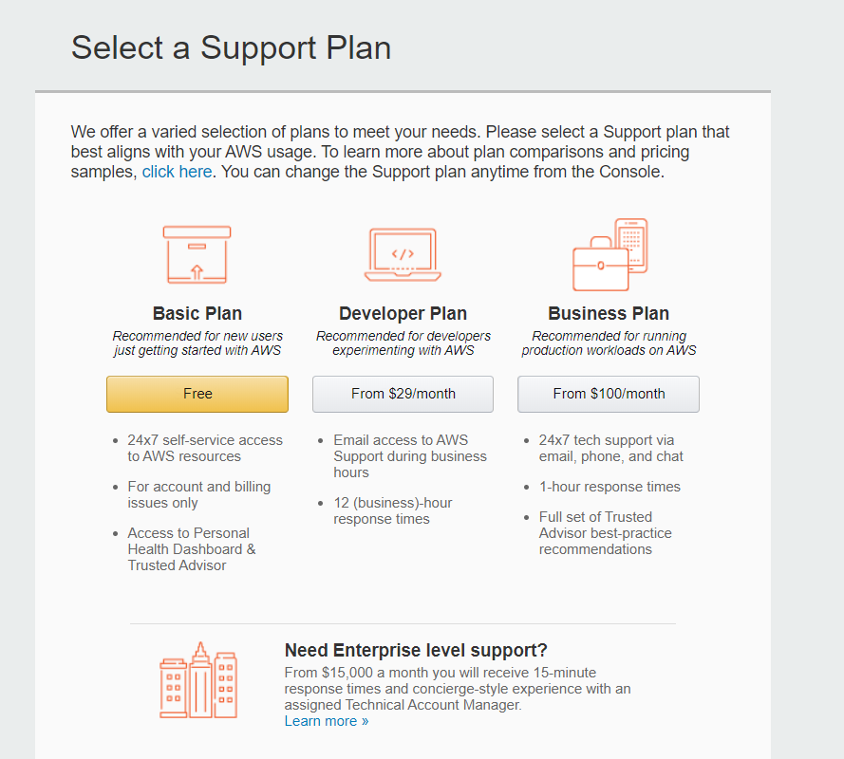

Step 8: If all steps are successful then you will get the below page. Select your role as below and submit and then click on “Sign in to the Console”. Top right corner.

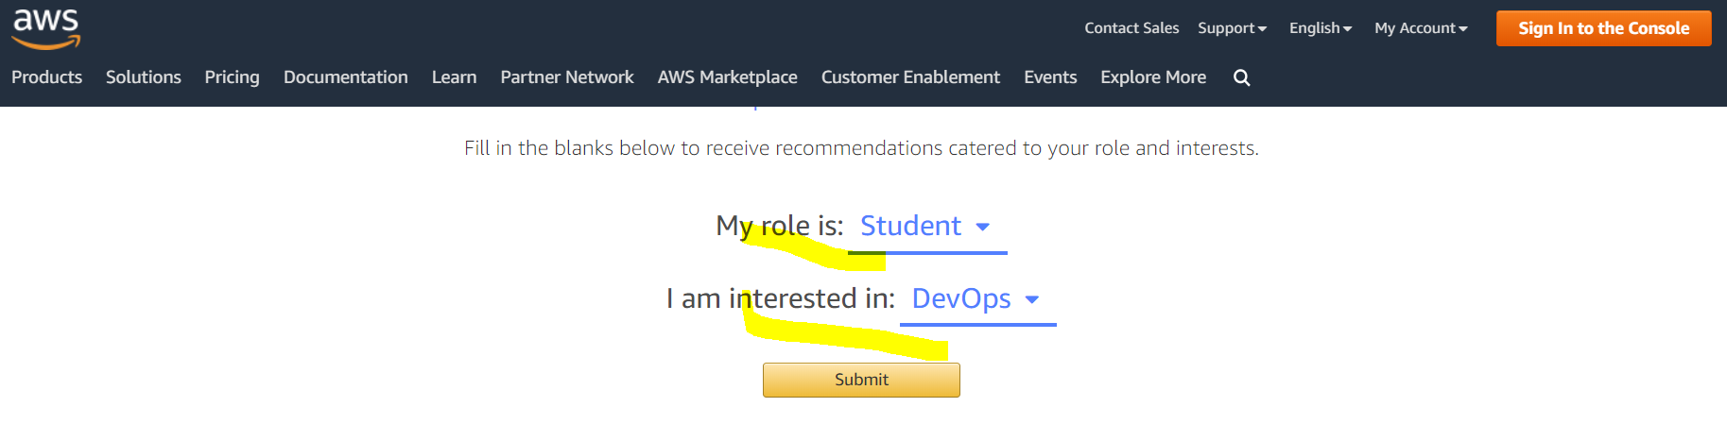

Step 9: Login with ur new account.

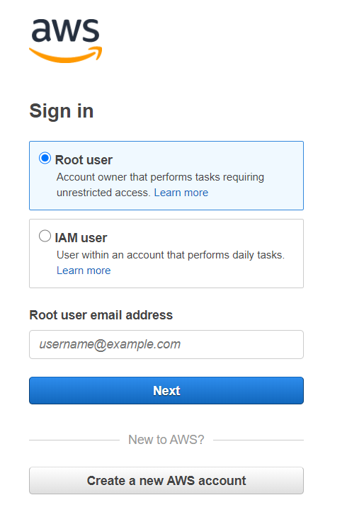

Step 10: Verify your details using below screenshot.

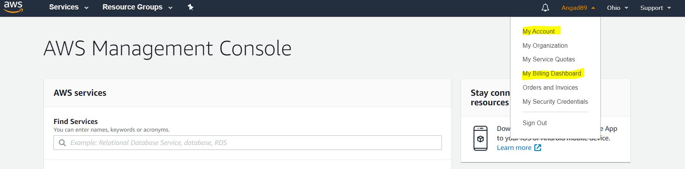

Step 11: Click on “My Account” and new page will open. Please verify your payment method.

**Issue 1: If your payment is not successful then please change your payment method and add new card and again 2 rs will be deducted and credited back to card.**

